Name: ________________________ Group #____ Topic # _____

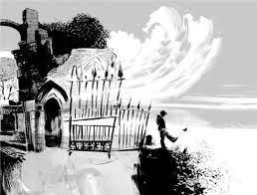
The Graveyard Book group encyclopedia
Directions:
You will be creating an encyclopedia page for one of the following topics (your topic has already been assigned to you in the top right hand corner of this page):
a. Neil Gaiman
b. Vampies
c. Werewolves
d. Ghosts
e. Ghouls
f. The 33rd President of the United States
g. Victor Hugo
h. Duke of Westminister

1. Research that topic using the links I have given you on the “GB Encyclopedia” assignment page on Canvas. Do not use any other websites! Find out important facts and details about your topic, as well as some interesting graphic to go along with your topic. Put as much information as you think is necessary to understand your topic, because the others in your group will be reading your page to do an assignment next week.

2. Put the information into the “Encyclopedia Page Template” from the assignment page.

3. Save the page to the desktop as your first and last name _ your topic
ex: Johnny Doe_vampires
4. Upload in these two ways:
1. Upload to dropitto.me/gbencyclopedia
password: miles
2. Upload it to your group’s file folder using the directions attached to this packet.

