Name: _________________________________________ Period: _____________
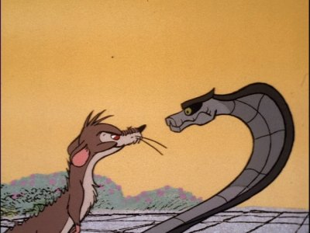
“Rikki-Tikki-Tavi” Comparison
1. After reading the story “Rikki-Tikki-Tavi,” what are some character traits you would use to describe the following characters (i.e. brave, compassionate, menacing, etc.)
Rikki-Tikki-Tavi:

Nag:

Nagaina:

Darzee:

Darzee’s Wife:

Chuchundra:

Teddy:

Teddy’s Father:

Teddy’s Mother:

2. Which version, the story or the film, do you think showcased those character traits best? Why?

3. Was there anything in the film that was not in the story? Why do you think they added it in?

4. Did they change anything from the original story for the film? Why did they, or why didn’t they change the story?

5. Do you think this filmed version was a good version of the story “Rikki-Tikki-Tavi”? Why or why not?

