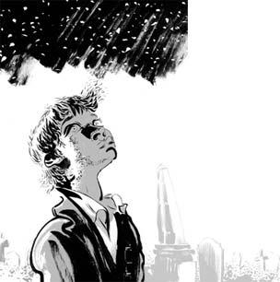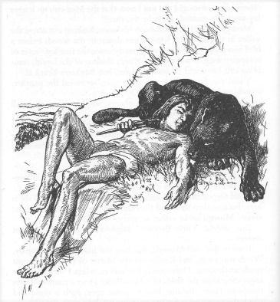
The Graveyard Book and The Jungle Book
Novel Comparison Study Expectations and Schedule
We will be reading The Graveyard Book and excerpts from The Jungle Book for the rest of the term. In order to finish these novels by the end of the term, you may be required to do some at-home reading. It is important that you complete this reading so you are prepared for class discussions, and so you can complete your assignments.

The following information will tell you what we will be doing with this unit, and the schedule of when we will be following.

Reading Assignments

1. Sticky Note Annotations

While reading The Graveyard Book, you will need to annotate your text with text connections, questions, and other thoughts. Since you are borrowing your novels from me, you can’t write in the actual book. Instead, I will provide you with sticky notes on which you can write your annotations, and then stick your notes into the book. You will turn in your novel to me with all of your completed sticky notes when we finish the novel. You must have 100 sticky notes in your text. On your sticky notes, you may choose to write any of the following:

- Connections to another text: any movies, books, television shows, current events, video games or song lyrics that you are reminded of for a specific plot element.
  - Example: When the ghosts in the graveyard have the council about Bod, it reminds me of Harry Potter and the Sorcerer’s Stone when Dumbledore, McGonagall and Hagrid drop Harry off at the Dursley’s and talk about his future.
- Questions: discussion questions or questions for further information
  - Example: Who is the Man Jack? Why is he after Bod?
- Unknown Words/Definitions: For any words you don’t know, write down the definition.
  - expostulate: to disagree or protest
- Quote reflection: for any quote from the text that you like, explain why it stands out to you, or why you like it
  - I like when it says, “He looks like nobody but himself” because every person looks exactly the way they are supposed to. You may think they look like someone else, but in reality, every person is different.

2. Chapter Quizzes, Reflections, and Discussion

For each chapter, you will be taking a quiz and doing reflection writing to hold you accountable for completing the reading. We will also do multiple types of discussion: pair-share, small group, and whole class.

3. Graveyard Book Encyclopedia

We are going to conduct a short research project in the computer lab where you will be researching some element of The Graveyard Book to make a class encyclopedia. You will be given their assigned element on that date.

4. Trivia Question Creation

You will get a chance to read the class Graveyard Book encyclopedia and create trivia questions for a Kahoot game based on the information you read.

5. Epitaph Poem

You will be writing an epitaph poem to go along with chapter 4 of The Graveyard Book. Further instructions will be given when we get closer to that part.

6. Missing Chapter Assignment

You will get to write a missing chapter “episode” for The Graveyard Book explaining another possible adventure Bod could have had in the graveyard. Further instructions will be given when we get closer to this assignment.

Comparative Essay

You will writing an essay comparing The Graveyard Book and The Jungle Book and it will be typed into Utah Compose. We will be filling out a comparison matrix as we read that will help you in writing this essay. It will be your “test” for this unit, so it is incredibly important that you are reading the novels and you don’t get too far behind.

Reading Schedule and Due Dates
We will follow the schedule on the next page as we read these two novels. It is subject to change as needed.

Date | In-class reading | At-home reading | Assignments and Due Dates
Sept. 20th | chapter 1 | finish chapter 1* | Novel Walkthrough  Mood and Imagery
Sept. 21st |  | chapter 2 pgs. 35-48 | Reading Drill charting
Sept. 22nd |  | finish chapter 2  pgs. 49-60 | The Graveyard Book Encyclopedia in computer lab
Sept. 23rd | “Mowgli’s Brothers” |  | comparison matrix
Sept. 26th | finish “Mowgli’s Brothers” |  | types of conflict notes and practice
Sept. 27th | chapter 3 |  | Similes and Metaphors
Sept. 28th |  |  | Reading Drill #3
Sept. 29th | chapter 3 | finish chapter 3* | Trivia Question Creation
Sept. 30th | “Kaa’s Hunting” |  | The Graveyard Book Trivia Game
Oct. 3rd | finish “Kaa’s Hunting” |  | comparison matrix
Oct. 4th | chapter 4 | read to pg. 119 (chapter 4)
Oct. 5th |  | read pgs. 120-134 (chapter 4) | Reading Drill #4
Oct. 6th | finish chapter 4 |  | Epitaph Poem
Oct. 10th | chapter 5 | finish chapter 5* | denotation vs. connotation
Oct. 11th | Interlude |  | simple and compound sentences
Oct. 12th | chapter 6 | read to pg. 191* | test-taking strategies
Oct. 13th |  |  | District Benchmark
Oct. 14th | finish chapter 6 | finish chapter 6*
Oct. 17th | chapter 7 | read to page 251*
Oct. 18th | chapter 7 | finish chapter 7*
Oct. 19th | chapter 8 |  | Due: Sticky Note Annotations
Oct. 24th | “Tiger, Tiger!” |  | comparison matrix
Oct. 25th | finish “Tiger, Tiger!” |  | begin comparative essay
Oct. 26th |  |  | Reading Drill charting  Finish draft of comparative essay
Oct. 27th |  | finish typing up essay* | Type comparative essay in Utah Compose
Nov. 3rd |  |  | Due: Comparative Essay
*only if we don’t get there in class

